LOGGED OUT – ISSUES (Free Plan)
- IND AS116 - Model 2: Escalation
- After clicking calculate button, Export button Button not working (99rs) showing the error as per the below screen shot
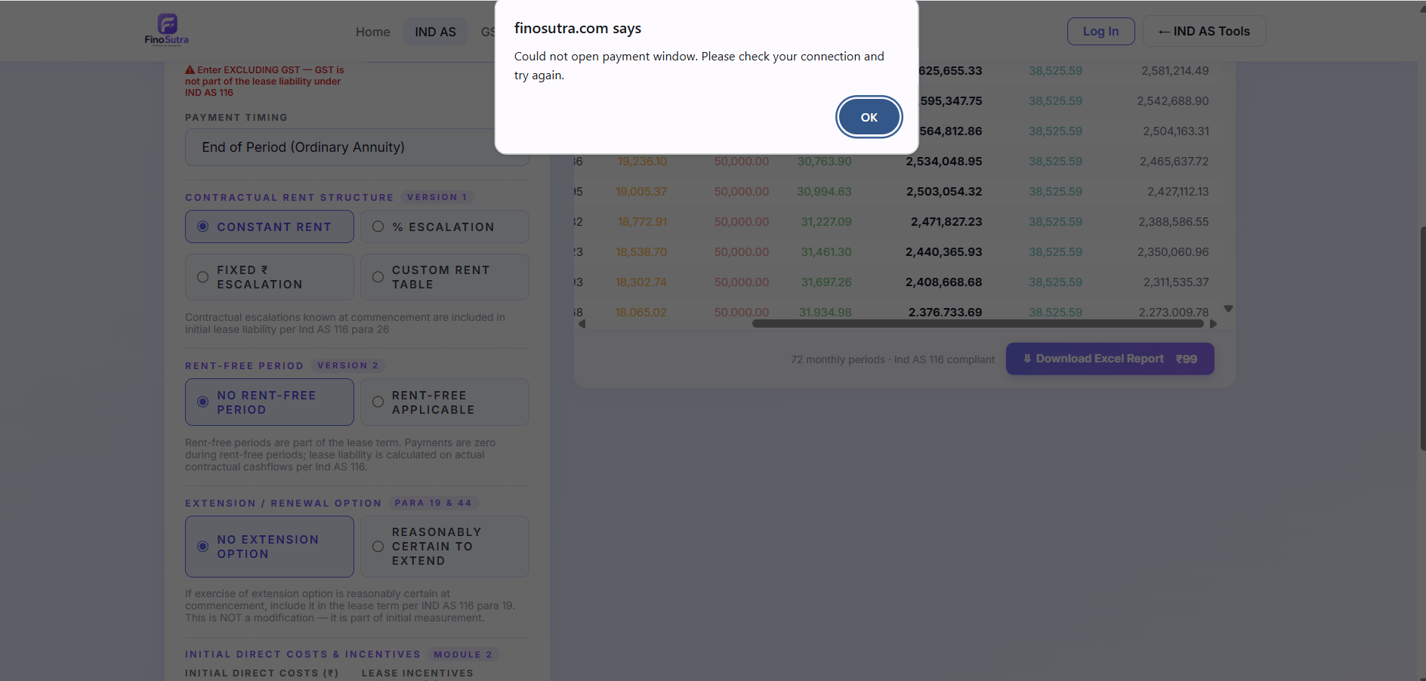

- Screen attached below should be maintained in all paid tools
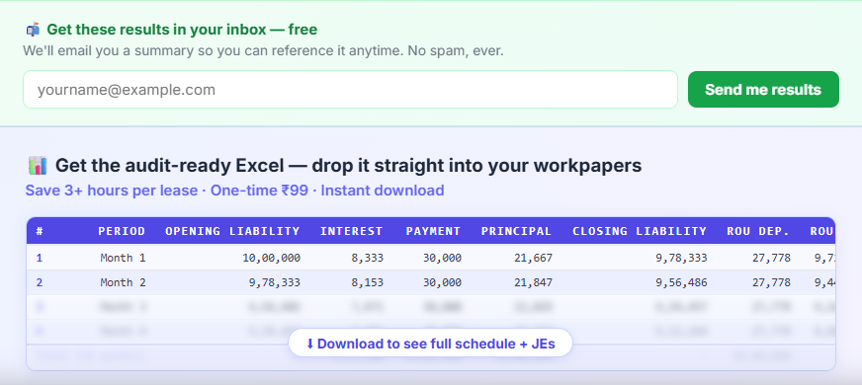

- IND AS116 – Standard
- After clicking calculate button, Export/Download excel report button Button (both button) not working (99rs).
- Income tax calculator:
- After clicking calculate button, Export button Button (both button) not working (99rs).
- Recalculate button at compute and compare page is also not working

LOGGED IN – ISSUES (Logged in with ca.krishnawadekar07@gmail.com Pro subscriber – 499 Paid plan)

- IND AS116 – Standard
- Still seeing the button, Export/Download excel report button (both button) not working (99rs). I tried click but no download happened , I am pro user it should be free to download instead of showing 99 rs excel export
- IND AS 116 – Model 2
- Still showing the 99 and 499 subscription and 99 rs button is working where as 499 razor payment window opening. As I am pro user both tab should be free to download excel file and no need to show 99 or 499
- Security deposit calculator:
- See below screen shot: Why this showing even if we are pro subscriber it should be given free to download. All 3 export buttons are working but they are redirecting to razor pay. It okay for free plan user not for pro user.
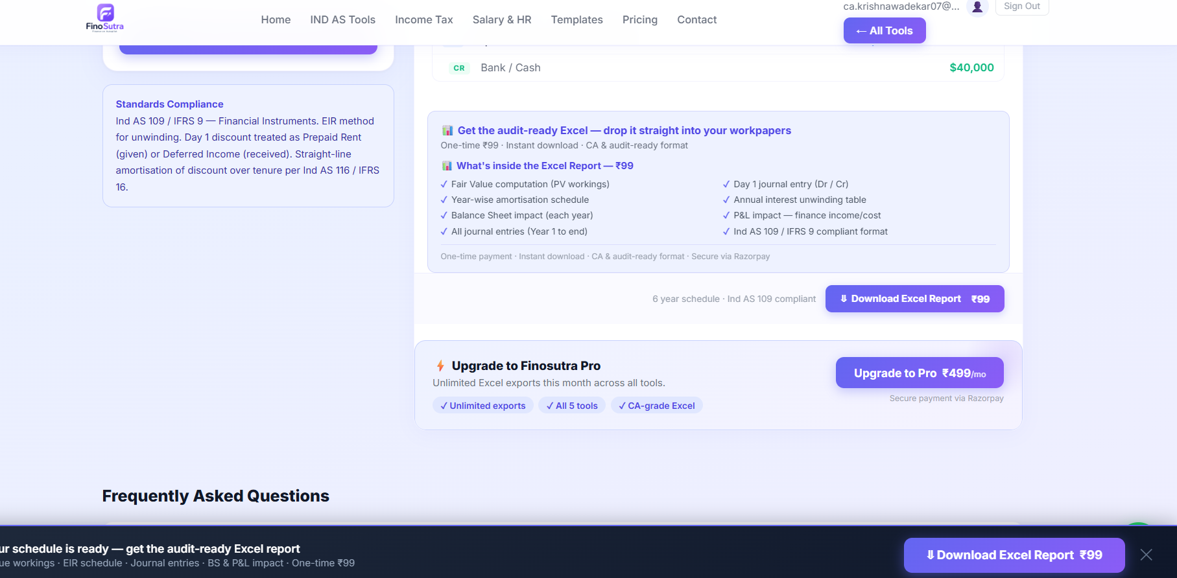

- Income tax calculator:
- After clicking calculate button, Export button Button (both button) not working (99rs). But if it works it should download the file freely not to charge 99.
- Recalculate button at compute and compare page is also not working.

